# Guide to manage plugins remotely

This document shows the way to manage plugins remotely.

Limitation:

1. Need to restart the website to reflect newly installed plugin. Actually, OSGi.NET can install plugin on fly and no need to restart the website, but to make the Asp.net code simple, I removed this feature, and I don’t think it’s a very useful feature either.

Steps,

1. Start the website “Asp.net MVC 4 Integration”, then it should look like this,

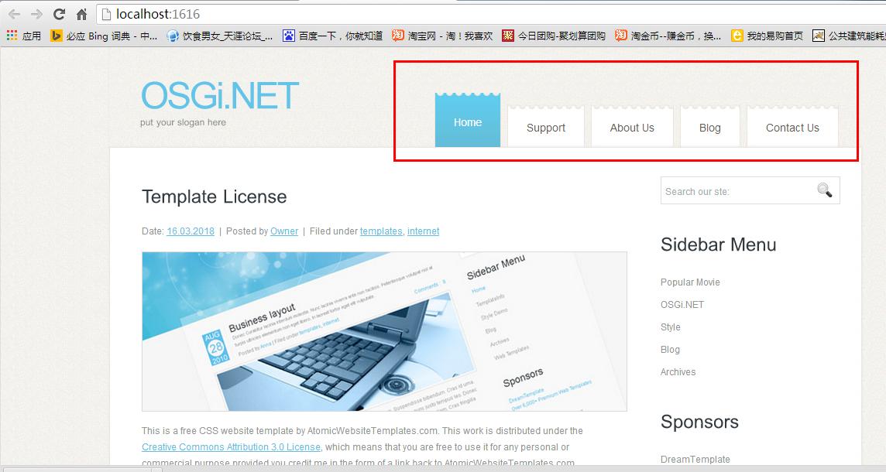  
The navigation bar are populated by plugins.

1. Start “UIShell.RemoteConsole.exe”, and keep Press Enter twice, then you will all available menus as below, 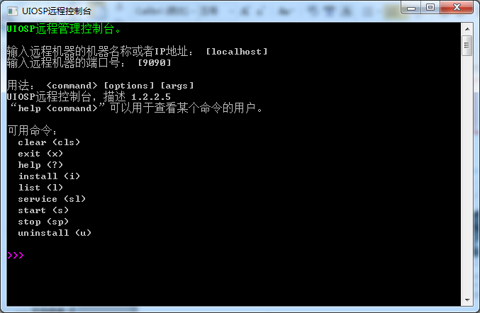
2. Input **l** and enter, you can see all plugins running in the website. 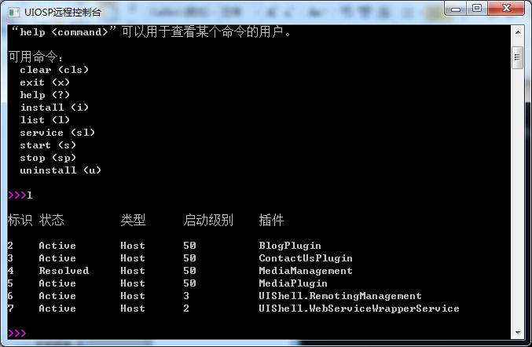

To stop one plugin, input **sp <<bundle id>>,** for instance, we can stop BlogPlugin like this:  
sp 2

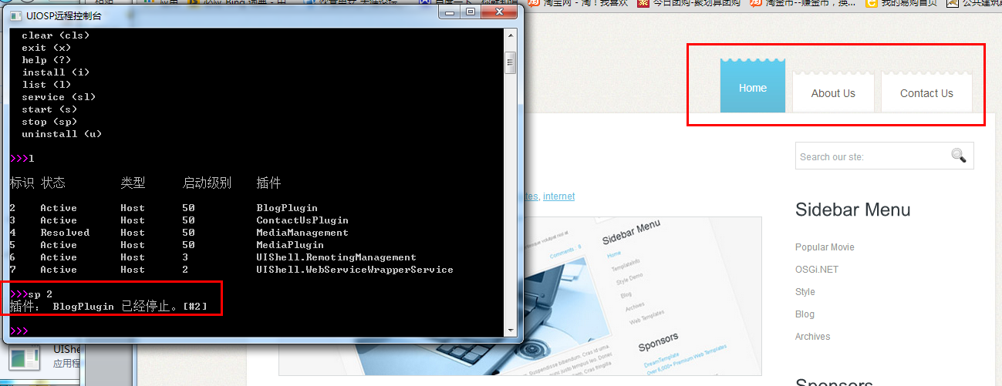

After stop one plugin, please refresh the page, and you will the plugin pages are gone.

To reload the pages, just need to start the plugin again, Start BlogPlugin by below command.

s 2

